**10**

**Rotation of a Rigid Object**

**About a Fixed Axis**

|  |
| --- |
| **CHAPTER OUTLINE** |

10.1 Angular Position, Velocity, and Acceleration

10.2 Analysis Model: Rigid Object Under Constant Angular Acceleration

10.3 Angular and Translational Quantities

10.4 Torque

10.5 Analysis Model: Rigid Object Under a Net Torque

10.6 Calculation of Moments of Inertia

10.7 Rotational Kinetic Energy

10.8 Energy Considerations in Rotational Motion

10.9 Rolling Motion of a Rigid Object

* An asterisk indicates a question or problem new to this edition.

|  |
| --- |
| **SOLUTIONS TO THINK-PAIR-SHARE AND ACTIVITIES** |

**\*TP10.1 Conceptualize** Consult Figure 10.14 in the textbook. The situation here is similar. The hanging block of mass *m* in the figure represents the pickax. The wheel in the figure represents the cylindrical artifact. To answer the question about the cylinder being hollow, we need to evaluate its moment of inertia and compare the result to moments of inertia in Table 10.2.

**Categorize** We need to combine several analysis models here. The cylindrical artifact is a *rigid object under a net torque*. The pickax is a *particle under a net force.* The pickax is also a *particle under constant acceleration*.

**Analyze** From the rigid object under a net torque model, write Equation 10.18 for the cylindrical artifact:

 (1)

where *T* is the tension in the twine, *R* and *I* are the radius and moment of inertia of the cylinder, and ** is its angular acceleration. From the particle under a net force model, write Equation 5.2 for the pickax:

 (2)

where *m* is the mass of the pickax and *a* is its translational acceleration. From the particle under constant acceleration model, write Equation 4.16 for the pickax:

 (3)

where *h* is the distance the pickax descends and *t* is the time at which it reaches the position –*h*. Write Equation 10.11 to relate the translational acceleration of the pickax and, therefore, the twine (as well as a point on the rim of the cylinder) to the angular acceleration of the cylinder:

*a* = *R* (4)

Substitute for ** in Equation (1) from Equation (4), and solve for *T*:

 (5)

Substitute into Equation (2) and solve for *I*:

 (6)

Express the moment of inertia as *I* = *fMR*2, where *f* is an unknown fraction, and solve for *f*:

 (7)

Finally, substitute Equation (3) for the acceleration of the pickax:

 (8)

(a) Substitute numerical values:



If the cylindrical object were solid and uniform, the fraction *f* would be 0.5, as we see in Table 10.2 for a solid cylinder. If the object were hollow with just a thin shell of material, the fraction *f* would be close to 1 (exactly 1 if it weren’t for the “end caps”), as we see at the upper left in Table 10.2. Because the fraction turns out to be between these two values, if we assume that the material is uniform throughout, it must be hollow, with a cross section such as that shown at the upper right in Table 10.2.

(b) Substitute the new time for the pickax to fall the same distance:



This fraction is *less* than the value of 0.5 in Table 10.2 for a solid cylinder of a uniformly dense material. This would suggest that the cylinder is not uniform. It might have a solid core of a more dense material at the center, or the density may vary continuously such that it increases closer to the axis of the cylinder.

**Finalize** Notice that we could determine some limited information about the inner construction of the cylinder without need for sophisticated scanning equipment. Notice also that we never used the radius of the cylinder in our numerical calculation.

*Answers:* (a) partially (b) not likely to be hollow

**\*TP10.2 Conceptualize** Think about the cars as their speed increases around the track. At some point, the static friction force, which is the only force providing their centripetal acceleration, reaches its maximum value and the cars break free, sliding to the outer edge of the track.

**Categorize** We will model each car several ways. A car is a *particle in equilibrium* in the vertical direction. It can be modeled as a *rigid object* (a particle on the end of a massless rod pivoted at the center of the circle) *under constant angular acceleration.* Each car is also modeled as a *particle under a net force* in the horizontal direction, with the acceleration in the radial direction being centripetal.

**Analyze** Model each car as a particle under a net force in the horizontal direction toward the center of the track. The acceleration of the car has both a radial and a tangential component:

 (1)

The tangential acceleration is that given in the problem: *at* = *a*. The radial acceleration is given by Equation 10.12: *ar* = *r*2:

 (2)

Now model the car as a rigid object under constant angular acceleration to find the angular speed at a given angular position. Write Equation 10.8:

 (3)

If we identify *i* = 0 as the angular position on the track at which the cars begin with *i* = 0, then *f* is ** that we need in Equation (2), and *f* is the angle ** at which the car has that angular speed. Make these substitutions in Equation (3):

 (4)

Now, replace the angular acceleration ** using Equation 10.11:

 (5)

Substitute Equation (5) into Equation (2):

 (6)

Now let’s introduce the fact that the car skids off the track. For that to happen, the horizontal force, which consists *only* of the force of static friction on the tires, must reach its maximum value so that the car breaks free from the surface and slides. So the skidding condition is described by substituting the maximum force of static friction on the left in Equation (6):

 (7)

where **skid is the angular position at which the car skids and we have used Equation 5.9 for the friction force. From the particle in equilibrium model for the car in the vertical direction, we have

 (8)

 (9)

Solve Equation (9) for the angle at which the car skids:

 (10)

The angle at which the cars skid in Equation (10) does *not* depend on the mass of the car. It depends on the acceleration of the car, but we stated that that was the same for all cars. It depends on the coefficient of static friction, but we stated that all cars had the same tires and were on the same roadway. Therefore, all cars skid at the same angular position around the track. Now, what about the new track with the larger radius? The radius of the track does not appear in Equation (10). Therefore, the cars will skid off the track at exactly the same angular position as they did for the smaller track!

**Finalize** This last result might be surprising, but keep in mind that it will take longer for the cars to arrive at this angular position on the larger track. Therefore, even though the turn is not as tight, they will be traveling with a higher speed at that angular position.

*Answer:* The cars slip at the same angle.

**\*TP10.3 Conceptualize** Relate this problem to the falling smokestacks discussed in Conceptual Example 10.5. The far end of the meterstick falls faster than a particle released from that point.

**Categorize.** We model the meterstick as a *rigid object under a net torque*.

**Analyze** (b) Write a torque equation for the meterstick, choosing a rotation axis passing through the 0-cm end:

 (1)

Use Equation 10.11 to substitute for the angular acceleration and solve for the translational acceleration of a point on the meterstick a distance *r* from the rotation axis:

 (2)

The torque is due to the gravitational force acting at the center of gravity, which is at the center of the meterstick, which is of length . Enter this information as well as the moment of inertia of the meterstick about its end:

 (3)

The meterstick will fall out from under a penny if the translational acceleration of that point on the meterstick is greater than that due to gravity: *at* > *g*. Set up this inequality and find the minimum position on the meterstick for which this is true:



Therefore, all points farther out on the meterstick than 67 cm will have a tangential acceleration larger than that at which the penny falls, and the meterstick will fall out from under the penny for those points.

**Finalize** What would happen if you taped some extra weight on the 100-cm end of the meterstick?

*Answers:* (a) Pennies from 70 cm onward should lose contact with the meterstick.

(b) All pennies on the meterstick beyond the 67-cm mark will lose contact with the stick as it falls.

|  |
| --- |
| **SOLUTIONS TO END-OF-CHAPTER PROBLEMS** |

Section 10.1 Angular Position, Velocity, and Acceleration

**P10.1** (a) The Earth rotates 2*π* radians (360°) on its axis in 1 day. Thus,



(b) Because of its angular speed, 

**P10.2 **





Section 10.2 Analysis Model: Rigid Object Under Constant Angular Acceleration

**P10.3** (a) We start with  and solve for the angular acceleration 



(b) The angular position of a rigid object under constant angular acceleration is given by Equation 10.7:



P10.4 (a) From , the angular displacement is



(b) From the equation given above for  observe that when the angular acceleration is constant, the displacement is proportional to the difference in the squares of the final and initial angular speeds. Thus, the angular displacement would  if both of these speeds were doubled.

**P10.5** We are given 

(a) 

(b) 

P10.6 According to the definition of average angular speed (Eq. 10.2), the disk’s average angular speed is 50.0 rad/10.0 s = 5.00 rad/s. According to the average angular speed expressed as  in the model of a rigid object under constant angular acceleration, the average angular speed of the disk is (0 + 8.00 rad/s)/2 = 4.00 rad/s. Because these two numbers do not match, the angular acceleration of the disk cannot be constant.

**P10.7** (a) Let *R*E represent the radius of the Earth. The base of the building moves east at  where *ω* is one revolution per day. The top of the building moves east at  Its eastward speed relative to the ground is  The object’s time of fall is given by  During its fall the object’s eastward motion is unimpeded so its deflection distance is



(b) 

(c) 

(d)  Because the displacement is proportional to angular speed and the angular acceleration is constant, the displacement decreases linearly in time.

**Section 10.3 Angular and Translational Quantities**

P10.8 Estimate the tire’s radius at 0.250 m and miles driven as 10 000 per year. Then,





**P10.9** (a) The final angular speed is



(b) We solve for the angular acceleration from :



(c) From the definition of angular acceleration,



P10.10 (a) 

(b) 

P10.11 (a) We first determine the distance travelled by the car during the 9.00-s interval:



the number of revolutions completed by the tire is then



(b) 

**P10.12** The object starts with  The location of its final position on the circle is found from 

(a) Its position vector is



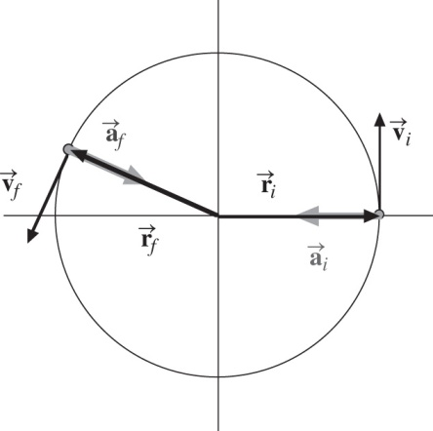

**ANS. FIG. P10.12**

(b) 

(c) The object’s velocity is (1.50 rad/s)(3.00 m) = 4.50 m/s at 90°. After the displacement, its velocity is



(d) .

(e) Its acceleration is v2/r, opposite in direction to its position vector. This is



(f) ANS. FIG. P10.12 shows the initial and final position, velocity, and acceleration vectors.

(g) The total force is given by



**P10.13** (a) The general expression for angular velocity is



where *ω* is in radians/second and *t* is in seconds.

The angular velocity will be a maximum when



Solving for the time t, we find



Placing this value for t into the equation for angular velocity, we find



(b) 

(c) The roller reverses its direction when the angular velocity is zero—recall an object moving vertically upward against gravity reverses its motion when its velocity reaches zero at the maximum height.



The driving force should be removed from the roller at 

(d) Set t = 2.78 s in the expression for angular position:



or 

**Section 10.4 Torque**

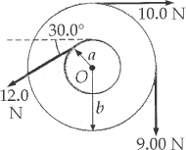**P10.14** To find the net torque, we add the individual torques, remembering to apply the convention that a torque producing clockwise rotation is negative and a counterclockwise rotation is positive.



**ANS. FIG. P10.14**

The thirty-degree angle is unnecessary information.

**Section 10.5 Analysis Model: Rigid Object Under a Net Torque**

P10.15 (a) The moment of inertia of the wheel, modeled as a disk, is



From Newton’s second law for rotational motion,



then, from  we obtain



(b) The number of revolutions is determined from



**P10.16** (a) See ANS. FIG. P10.16 below for the force diagrams. For *m*1,  gives





with 

gives

 **[1]**

For the pulley,  gives



or  **[2]**

For *m*2,





 **[3]**

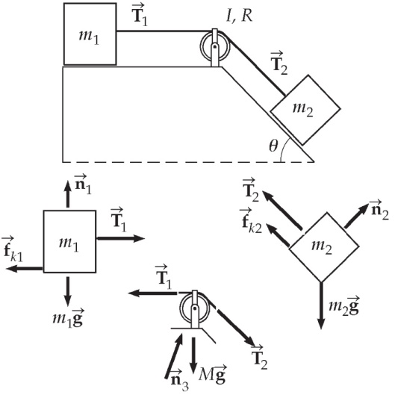

**ANS. FIG. P10.16**

(b) Add equations [1], [2], and [3] and substitute the expressions for f*k*1 and n1, and –f*k*2 and n2:





(c) From equation [1]:

 

From equation [2]: 



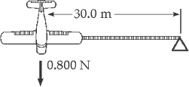P10.17 We use the definition of torque and the relationship between angular and translational acceleration, with *m* = 0.750 kg and *F* = 0.800 N:

ANS. Fig. P10.17

(a) 

(b) 

(c) 

**P10.18** (a) The chosen tangential force produces constant torque and therefore constant angular acceleration. Since the disk starts from rest, we write



Solving for the angular acceleration gives



We then obtain the required combination of *F* and *R* from the rigid object under a net torque model:





(b) 

**\*P10.19 Conceptualize** If you have not seen a potter’s wheel in operation, check online for images and videos.

**Categorize** We model the wheel as a *rigid object under a net torque* due to the friction force from the rag on its edge. Because the force applied by the rag is constant, we also model the wheel as a *rigid object under constant angular acceleration*.

**Analyze** (a) Write the torque equation for a rigid object under a net torque:

 (1)

The torque is due to the friction force, which is directed perpendicularly to the radius of the wheel. The constant acceleration can be substituted from Equation 10.6 in the rigid object under constant angular acceleration model:

 (2)

where we have used the moment of inertia of a disk from Table 10.2 and have defined *t* = 0 as the instant the force is first applied to the edge of the wheel. The force applied radially inward by your grandmother is a normal force on the edge of the wheel, so we can replace the friction force in Equation (2) with *fk* = *kn* = *kF*, where *F* is the inward force applied by your grandmother. Let’s also identify *f* = 0 so that *t* is the time at which the wheel stops:

 (3)

Substitute numerical values, using the maximum force with which your grandmother can push inward on the wheel:



(b) From the rigid object under a net torque model,  gives

 (4)

where *r* is the radial distance to the point of contact of the rag with the wheel and *R* is the radius of the wheel. The negative sign indicates that the direction of the torque due to friction is opposite to that of the initial angular speed of the wheel. Solving Equation (4) for the force *F* and substituting numerical values then gives



**Finalize** Given this information, if you design a brake that pushes inward on the edge of the wheel with the same force as your grandmother, your brake must have a coefficient of kinetic friction greater than 0.312.

*Answers:* (a) 0.312 (b) 117 N

**\*P10.20 Conceptualize** Use the image of an unwinding yo-yo to visualize the situation. The yo-yo in this situation is simplified compared to a typical toy yo-yo, which has the string wrapped around an axle that is of a different diameter than two outer disks. In our problem, the rope is wrapped around the outer surface of a cylindrical container, which unwinds off the rope.

**Categorize** As the container unrolls off the rope, it can be modeled as a *rigid object under a net torque,* as well as a *particle under a net force*. All of the forces in the problem are constant, so the container will descend as a *particle under constant acceleration*. In addition, the Earth and the container can be modeled as an *isolated system* for *energy*.

**Analyze** The diagram below shows the physical setup, as well as the forces on the container of radius *R*: the gravitational force and the force from the rope whose magnitude is the tension *T*.

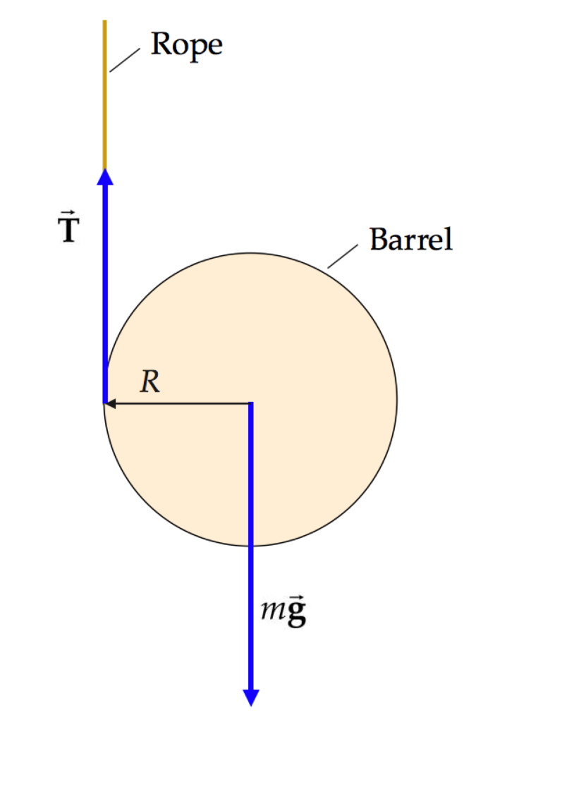

Apply the particle under a net force model to the container, choosing downward as the positive direction:

 (1)

Apply the rigid object under a net torque model to the container, with the rotation axis through the center of the container:

 (2)

Because the container is rolling off the rope, relate the acceleration *a* of the center of mass of the container to the angular acceleration ** of the container by using Equation 10.11:

 (3)

Substitute Equation (3) into Equation (2) and the result into Equation (1) to find the acceleration of the center of mass of the container:

 (4)

Model the center of the container as a particle under constant acceleration. Equation 4.9 gives us

 (5)

Call the initial position *yi* = 0 and the final position *yf* = *h*. Releasing the container from rest, Equation (5) becomes

 (6)

where we have incorporated our condition that downward is positive. Substituting Equation (4) into Equation (6) gives

 (7)

which is the time at which the container arrives at a position a distance *h* below the surface. Now apply the isolated system model for energy to the container and the Earth, choosing the instant of release as the initial configuration and the final configuration (for which *Ug* = 0) as when the container reaches a position a distance *h* below the surface:



Finally, because the container is rolling off the rope, relate the speed *v* of the center of mass of the container to the angular speed ** of the container by using Equation 10.28 (*v*CM = *R*) and substitute into Equation (8):

 (9)

Now, we can address our two questions given in the problem: Equation (7) provides the time at which the container reaches a position a distance *h* below the surface, and Equation (9) gives us the speed of the container at that position.

(a) If we want the container to reach the bottom in the shortest time interval, we want to minimize the time found in Equation (7). The only variable over which we have control is the moment of inertia *I*. Because of the position of *I* in Equation (7), minimizing *I* will minimize the time *t*. Therefore, we want to pack the heavy water bottles at the center of the container.

(b) To minimize the speed *v*CM at which the container arrives at the bottom of the shaft, we wish to minimize Equation (9). Because of the position of *I* in Equation (9), *maximizing* *I* will minimize the speed *v*CM. Therefore, we want to pack the heavy water bottles near the outer edges of the container.

**Finalize** Note that this problem differs from many other problems because the rotating object is not of uniform density. In this problem, we have control over the mass distribution in the container and can therefore control in some way the motion of the container as it unrolls off the rope.

*Answers:* (a) at the center (b) near the edges

*P10.21 **Conceptualize** Figure P10.21 helps us to understand the physical setup. Because the wheel is slowing down due to frictional torque, the drops are projected upward with less speed and don't rise as high as the preceding drop.

**Categorize** A particular drop and the Earth can be modeled as an *isolated system* for *energy*. We model the bicycle wheel as a *rigid object under constant angular acceleration* and a *rigid object under a net torque*.

**Analyze**  Write the appropriate reduction of Equation 8.2 for the system of an upward-moving drop and the Earth between the time the drop leaves the wheel and the time it stops momentarily at its highest point:

 (1)

Substitute for the initial and final energies and solve for the speed with which a drop is projected upward:

 (2)

Because the drop comes from the rim of the rotating wheel, the initial speed of the drop as it is projected upward is the same as the tangential speed of the rim of the wheel. Using Equation 10.10, we can find the angular speed of the wheel:

 (3)

Now, model the wheel as a rigid object under constant angular acceleration. Find the angular acceleration of the wheel from Equation 10.8 and substitute for the angular speeds:



where we have indicated the final angle as 2** because the wheel made one revolution between measurements of the drop heights. The only torque on the wheel is the frictional torque, so find this from the rigid object under a net torque model:



Substitute numerical values:



**Finalize** Notice that we never needed the radius of the wheel in the final algebraic solution, so that measurement was unnecessary. The frictional torque on your wheel is larger in magnitude than the limit of 0.02 N · m indicated by the technician, so you should take the bicycle in for repairs.

Answer: τf = −0.039 8 N ⋅ m

**Section 10.6 Calculation of Moments of Inertia**

P10.22 Model your body as a cylinder of mass 60.0 kg and a radius of 12.0 cm. Then its moment of inertia is



**P10.23** We use x as a measure of the distance of each mass element dm in the rod from the *y*′ axis:



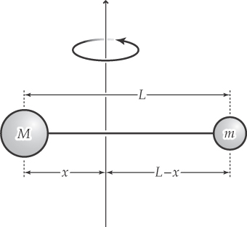**P10.24** (a) We take a coordinate system with mass M at the origin. The distance from the axis to the origin is also x. The moment of ineria about the axis is



To find the extrema in the moment of inertia, we differentiate *I* with respect to *x*:

ANS. Fig. P10.24



Solving for *x* then gives



Differentiating again gives ; therefore, I is at a minimum when the axis of rotation passes through  which is also the position of the center of mass of the system if we take mass *M* to lie at the origin of a coordinate system.

(b) The moment of inertia about an axis passing through x is



**Section 10.7 Rotational Kinetic Energy**

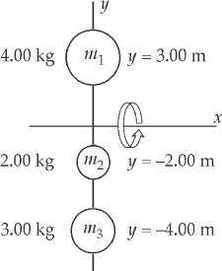P10.25 The masses and distances from the rotation axis for the three particles are:







and  about the x axis.

ANS. Fig. P10.25

(a) 



(b) 

(c) 





(d) 







(e)  Rotational kinetic energy of an object rotating about a fixed axis can be viewed as the total translational kinetic energy of the particles moving in circular paths.

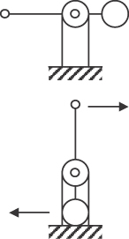**P10.26** (a) Identify the two objects and the Earth as an isolated system. The maximum speed of the lighter object will occur when the rod is in the vertical position so let’s define the time interval as from when the system is released from rest to when the rod reaches a vertical orientation. So, for the isolated system,



ANS. Fig. P10.26



Then, the tangential speed of the lighter object is,



(b)  The overall acceleration is not constant. It has to move either in a straight line or parabolic path to have a chance of being under constant acceleration. The circular path presented here rules out that possibility.

(c)  It does not move with constant tangential acceleration, since the angular acceleration is not constant. See explanation in part (d).

(d)  The lever arm of the gravitational force acting on the 60-kg mass changes during the motion. As a result, the torque changes, and so does the angular acceleration.

(e)  The angular velocity changes, therefore the angular momentum of the trebuchet changes.

(f)  The mechanical energy stays constant because the system is isolated—that is how we solved the problem in (a).

**Section 10.8 Energy Considerations in Rotational Motion**

**P10.27** The moment of inertia of a thin rod about an axis through one end is . The total rotational kinetic energy is given as



with 

and 

In addition,



while 

Therefore,



**10P10.28** Take the two objects, pulley, and Earth as the system. If we neglect friction in the system, then mechanical energy is conserved and we can state that the increase in kinetic energy of the system equals the decrease in potential energy. Since *Ki* = 0 (the system is initially at rest), we have



ANS. Fig. P10.28

where *m*1 and *m*2 have a common speed. But  so that .

From ANS. FIG. P10.28, we see that the system loses potential energy because of the motion of *m*1 and gains potential energy because of the motion of *m*2. Applying the law of conservation of energy,  gives





Since , the angular speed of the pulley at this instant is given by



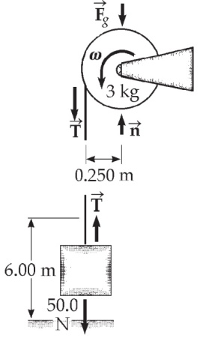**P10.29** The gravitational force exerted on the reel is

**

We use  to find *T* and *a*.

First find *I* for the reel, which we know is a uniform disk.



ANS. Fig. P10.29

The forces on the reel are shown in ANS. FIG. P10.29, including a normal force exerted by its axle. From the diagram, we can see that the tension is the only force that produces a torque causing the reel to rotate.

 becomes

 **[1]**

where we have applied *at* =  to the point of contact between string and reel. For the object that moves down,

 **[2]**

Note that we have defined downwards to be positive, so that positive linear acceleration of the object corresponds to positive angular acceleration of the reel. We now have our two equations in the unknowns *T* and *a* for the two connected objects. Substituting *T* from equation [2] into equation [1], we have



(b) Solving for a from above gives



Because we eliminated *T* in solving the simultaneous equations, the answer for *a*, required for part (b), emerged first. No matter—we can now substitute back to get the answer to part (a).

(a) *T* = 50.0 N – 5.10 kg (7.57 m/s2) = 

(c) For the motion of the hanging weight,





(d) The isolated-system energy model can take account of multiple objects more easily than Newton’s second law. Like your bratty cousins, the equation for conservation of energy grows between visits. Now it reads for the counterweight-reel-Earth system:

(*K*1 + *K*2 + *Ug*)*i* = (*K*1 + *K*2 + *Ug*)*f*

where *K*1 is the translational kinetic energy of the falling object and *K*2 is the rotational kinetic energy of the reel.



Now note that *ω* = *v*/*r* as the string unwinds from the reel.







**P10.30** The power output of the bus is  where



is the stored energy and  is the time it can roll. Then  The maximum range of the bus is then 

For average  and average   
*v* =35.0 km/h = 9.72 m/s, the maximum range is





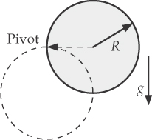**P10.31** To identify the change in gravitational energy, think of the height through which the center of mass falls. From the parallel-axis theorem, the moment of inertia of the disk about the pivot point on the circumference is



ANS. Fig. P10.31

The pivot point is fixed, so the kinetic energy is entirely rotational around the pivot. The equation for the isolated system (energy) model

(*K* + *U*)*i* = (*K* + *U*)*f*

for the disk-Earth system becomes



Solving for  

(a) At the center of mass, 

(b) At the lowest point on the rim, 

(c) For a hoop,



By conservation of energy for the hoop-Earth system, then



so 

and the center of mass moves at  slower than the disk.

**P10.32** Each point on the cord moves at a linear speed of  where *r* is the radius of the spool. The energy conservation equation for the counterweight-turntable-Earth system is:

(*K*1 + *K*2 + *Ug*)*i* + *W*other = (*K*1 + *K*2 + *Ug*)*f*

Specializing, we have







and finally,



**P10.33** (a) Energy conservation for the system of the ball and the Earth between the horizontal section and top of loop:





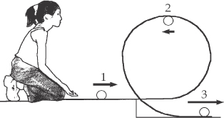

ANS. Fig. P10.33

(b) The centripetal acceleration at the top is



Thus, the ball must be in contact with the track, with the track pushing downward on it.

(c) 



(d) 



(e) This result is imaginary. In the case where the ball does not roll, the ball starts with less kinetic energy than in part (a) and never makes it to the top of the loop.

**P10.34** (a) Both systems of cube-Earth and cylinder-Earth are isolated; therefore, mechanical energy is conserved in both.  has extra kinetic energy, in the form of rotational kinetic energy, that is available to be transformed into potential energy, so it travels farther up the incline.

(b) The system of cube-Earth is isolated, so mechanical energy is conserved:



Static friction does no work on the cylinder because it acts at the point of contact and not through a distance; therefore, mechanical energy is conserved in the cylinder-Earth system:



which gives 

The difference in distance is



or, the cylinder travels 50% farther.

(c) 

**P10.35** (a) For the isolated can-Earth system,



which gives



From the particle under constant acceleration model,



Therefore, the moment of inertia is



Substitute numerical values:



(b) The  is unnecessary data.

(c) 

**Additional Problems**

**\*P10.36 Conceptualize** Consult Figure 10.13 for a photograph of a smokestack breaking as it falls.

**Categorize** Model the falling smokestack as a *rigid object under a net torque.*

**Analyze** From the rigid object under a net torque model, write Equation 10.18 for the smokestack:

 (1)

The torque is supplied by the gravitational force on the smokestack, which can be imagined as acting at the center of mass of the smokestack. The smokestack is roughly cylindrical, so the center of mass would be about at the midpoint of its vertical height *h*. For a given angle ** that the falling smokestack makes with the vertical at some instant, the torque about the base of the smokestack can be expressed in terms of that angle:

 (2)

Model the smokestack as a long, thin rod, so that its moment of inertia about its base can be approximated from Table 10.2:

 (3)

Solve for the angular acceleration of the rod:

 (4)

Use Equation 10.11 to find the translation acceleration of an arbitrary point on the rod a distance *r* from its base:

 (5)

The component of the gravitational acceleration perpendicular to the rod is *g*sin **. Imagine a position *r* on the rod for which the tangential acceleration is larger than the acceleration component due to gravity:

 (6)

Therefore, for the top third of the rod, the tangential acceleration is larger than that provided by gravity alone in this simple model. If the toppling rod has a large shear strength, the shear forces between parts of the rod can provide this acceleration and the rod falls over undamaged; witness a pencil falling to the table from a vertical position.

A smokestack, however, is a collection of blocks held together with mortar. It is designed to maintain its vertical position for years; it is not designed to fall over. Therefore, there may be points in the smokestack, especially if it is old, where its shear strength is relatively low. Therefore, as the stack falls, there may not be enough shear force for the lower portion of the stack to provide the required acceleration of the upper part. As a result, the smokestack ruptures.

The demolition company should have known that potentially destructive shear forces would occur as the smokestack was lowered. They should have done a thorough analysis of the shear strength of the smokestack, and should have alerted the factory owners concerning the risks. They should not have *guaranteed* an undamaged smokestack.

**Finalize** There were a lot of assumptions made in this calculation. The falling of a smokestack is a complicated event. In reality, a smokestack is not necessarily cylindrical and may not be well modeled as a long, thin rod. Furthermore, there are many complications that we have not addressed. A real smokestack is not the same everywhere along its length. There may be weak spots that are more likely to rupture than other spots. The way the smokestack is mounted on its base will affect its falling and possible rupture: Does it fall freely, or is it still attached at the base as it falls? So a falling smokestack could rupture at a wide range of points along its length. There are online videos of smokestacks falling to the ground *without* breaking. While there is a possibility that the demolition company could have delivered an intact, horizontal smokestack, they could not *guarantee* it. If the demolition company guaranteed an intact smokestack, they are in the wrong. If they told the factory owner they could make an attempt, but that the smokestack might break on the way down, then the factory owner does not have a case.

*Answer:* The demolition company should not have guaranteed an undamaged smokestack. Strong shear forces act on the stack as it falls and, without performing an analysis of the shear strength of the stack, such a guarantee should not have been made.

P10.37 (a) We find the angular speed by integrating the angular acceleration, which is given as , where  is in rad/s2 and t is in seconds:



where  is in rad/s and t is in seconds.

For *t* = 3.00 s: 

(b) 

Suppressing units,



At *t* = 3.00 s,



P10.38 (a) We find the angular speed by integrating the angular acceleration, which is given as , where the shaft is turning at angular speed *ω* at time *t* = 0.



(b) 



**P10.39** (a) We consider the elevator-sheave-counterweight-Earth system, including n passengers, as an isolated system and apply the conservation of mechanical energy. We take the initial configuration, at the moment the drive mechanism switches off, as representing zero gravitational potential energy of the system.

Therefore, the initial mechanical energy of the system [elevator (e), counterweight (c), sheave (s)] is



The final mechanical energy of the system is entirely gravitational because the system is momentarily at rest:



where we have recognized that the elevator car goes up by the same distance d that the counterweight goes down. Setting the initial and final energies of the system equal to each other, we have







(b) For 

(c) For 

(d) For 

(e) 

(f) 

(g) For 

**P10.40** Consider the total weight of each hand to act at the center of gravity (midpoint) of that hand. Then the total torque (taking CCW as positive) of these hands about the center of the clock is given by



If we take *t* = 0 at 12 o’clock, then the angular positions of the hands at time *t* are  where  and  where  Therefore,



or , where *t* is in hours.

(a) (i) At 3:00, *t* = 3.00 h, so



(ii) At 5:15,  and substitution gives:



(iii) At 6:00, 

(iv) At 8:20, 

(v) At 9:45, 

(b) The total torque is zero at those times when



We proceed numerically, to find 0, 0.515 295 5, ..., corresponding to the times

|  |  |  |  |  |
| --- | --- | --- | --- | --- |
| 12:00:00 | 12:30:55 | 12:58:19 | 1:32:31 | 1:57:01 |
| 2:33:25 | 2:56:29 | 3:33:22 | 3:56:55 | 4:32:24 |
| 4:58:14 | 5:30:52 | 6:00:00 | 6:29:08 | 7:01:46 |
| 7:27:36 | 8:03:05 | 8:26:38 | 9:03:31 | 9:26:35 |
| 10:02:59 | 10:27:29 | 11:01:41 | 11:29:05 |  |

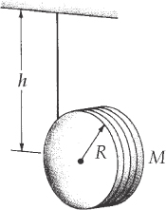**P10.41** Choosing positive linear quantities to be downwards and positive angular quantities to be clockwise,  yields



 then becomes

**ANS. FIG. P10.41**



(a) Setting these two expressions equal,



1. Substituting back,



(c)   gives us 

or 

(d) Now we verify this answer. Requiring conservation of mechanical energy for the disk-Earth system, we have

*Ui + K*rot, *i* *+ K*trans, *i* = *Uf +* *K*rot, *f* + *K*trans, *f*





When there is no slipping,  and 



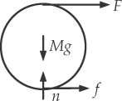P10.42 (a) From the particle under a net force model in the *x* direction, we have



ANS. fig. p10.42

From the particle under a net torque model,



Combining the two equations, and noting that  gives



(b) assuming friction is to the right, then



The facts that (1) we assumed that friction is to the right in Figure P10.82 and (2) our value for f comes out positive indicate that the friction force must indeed be to the right.

(c) From the kinematic equations,



or



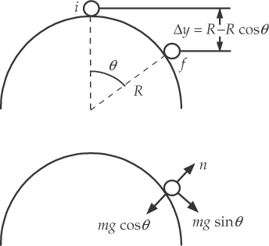P10.43 The grape-Earth system is isolated, so mechanical energy in that system is conserved. Between top of the clown’s head and the point where the grape leaves the surface:



..



ANS. fig. p10.43

which gives

 **[1]**

Consider the radial forces acting on the grape:



At the point where the grape leaves the surface,  Thus,



Substituting this into equation [1] gives



or 

**Challenge Problems**

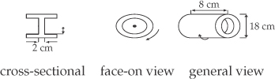**P10.44** For large energy storage at a particular rotation rate, we want a large moment of inertia. To combine this requirement with small mass, we place the mass as far away from the axis as possible.

ANS. Fig. P10.44

We choose to make the flywheel as a hollow cylinder 18.0 cm in diameter and 8.00 cm long. To support this rim, we place a disk across its center. We assume that a disk 2.00 cm thick will be sturdy enough to support the hollow cylinder securely.

The one remaining adjustable parameter is the thickness of the wall of the hollow cylinder. From Table 10.2, the moment of inertia can be written as





For the required energy storage,





The inner radius of the flywheel is 7.68 cm. The mass of the flywheel is then 7.27 kg, found as follows:



If we made the thickness of the disk somewhat less than 2.00 cm and the inner radius of the cylindrical wall less than 7.68 cm to compensate, the mass could be a bit less than 7.27 kg.



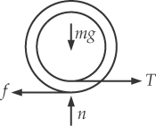P10.45 (a) reads  If we take torques around the center of mass, we can use  which reads  For rolling without slipping, . By substitution,

ANS. fig. p10.45





(b) Since the answer is positive, the friction force is confirmed to be 

P10.46 (a) If we number the loops of the spiral track with an index n, with the innermost loop having n = 0, the radii of subsequent loops as we move outward on the disc is given by r = ri + hn. Along a given radial line, each new loop is reached by rotating the disc through  Therefore, the ratio  is the number of revolutions of the disc to get to a certain loop. This is also the number of that loop, so  Therefore, 

(b) Starting from  we substitute the definition of angular speed on the left and the result for r from part (a) on the right:



(c) Rearrange terms in preparation for integrating both sides:



and integrate from  to  and from *t* = 0 to *t* = *t*:



We rearrange this equation to form a standard quadratic equation in *θ*:



The solution to this equation is



where we have chosen the positive root in order to make the angle *θ* positive.

(d) We differentiate the result in (c) twice with respect to time to find the angular acceleration, resulting in



Where we have used  Because this expression involves the time t, the angular acceleration is not constant.

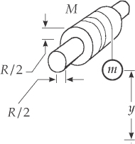P10.47  will oppose the torque due to the hanging object:

 **[1]**

Now find T, I, and *α* in given or known terms and substitute into equation [1].

 **[2]**

**ANS. FIG. 10.47**

also,  **[3]**

and  **[4]**

with  **[5]**

Substituting [2], [3], [4], and [5] into [1], we find



P10.48 (a) From the isolated system model for the block-pulley-Earth system,



(b) From the particle under constant acceleration model for the block,



|  |
| --- |
| **ANSWERS TO QUICK-QUIZZES** |

**1. (i)** (c) **(ii)** (b)

**2.** (b)

**3. (i)** (b) **(ii)** (a)

**4.** (b)

**5.** (b)

**6.** (a)

**7.** (b)

|  |
| --- |
| **ANSWERS TO EVEN-NUMBERED PROBLEMS** |

P10.2 144 rad

P10.4 (a) 3.5 rad; (b) increase by a factor of 4

P10.6 Because the disk’s average angular speed does not match the average angular speed expressed as  in the model of a rigid object under constant angular acceleration, the angular acceleration of the disk cannot be constant.

P10.8 ~107 rev/yr

P10.10 (a) 5.77 cm; (b) Yes. See P10.10 for full explanation.

P10.12 (a)  (b) It is in the second quadrant, at 156°;   
(c)  (d) It is moving toward the third quadrant, at 246°; (e)  (f) See ANS. FIG. P10.12;   
(g) 

P10.14 23.55 N . m

P10.16 (a) See ANS. FIG. P10.16; (b) 0.309 m/s2; (c) *T*1 = 7.67 N, *T*2 = 9.22 N

P10.18 (a) For *F* = 25.1 N, *R* = 1.00 m. For *F* = 10.0 N, *R* = 25.1 m; (b) No. Infinitely many pairs of values that satisfy this requirement may exist: for any *F* ≤ 50.0 N, *R* = 25.1 N ⋅ m/*F*, as long as *R* ≤ 3.00 m.

P10.20 (a) at the center (b) near the edges

P10.22 100 kg ⋅ m2 = 1 kg ⋅ m2

P10.24 (a) See P10.24 (a) for full description; (b) See P10.24 (b) for full description

P10.26 (a) 24.5 m/s (b) no (c) no (d) no (e) no (f) yes

P10.28  and 

P10.30 The situation is impossible because the range is only 3.86 km, not city-wide.

P10.32 

P10.34 (a) the cylinder; (b) ; (c) The cylinder does not lose mechanical energy because static friction does not work on it. Its rotation means that it has 50% more kinetic energy than the cube at the start, and so it travels 50% farther up the incline.

P10.36 The demolition company should not have guaranteed an undamaged smokestack. Strong shear forces act on the stack as it falls and, without performing an analysis of the shear strength of the stack, such a guarantee should not have been made.

P10.38  (b) 

P10.40 (a) (i) –794 N . m, (ii) –2 510 N . m, (iii) 0 N . m, (iv) –1 160 N . m,   
(v) 2 940 N . m; (b) See P10.40 (b) for full description.

P10.42 (a)  (b)  (c) 

P10.44 See P10.44 for full design and specifications of flywheel.

P10.46 (a) See P10.46 (a) for full solution; (b) See P10.46 (g) for full solution;

(c) (d) 

P10.48 (a) See P10.48 (a) for full explanation; (b) 